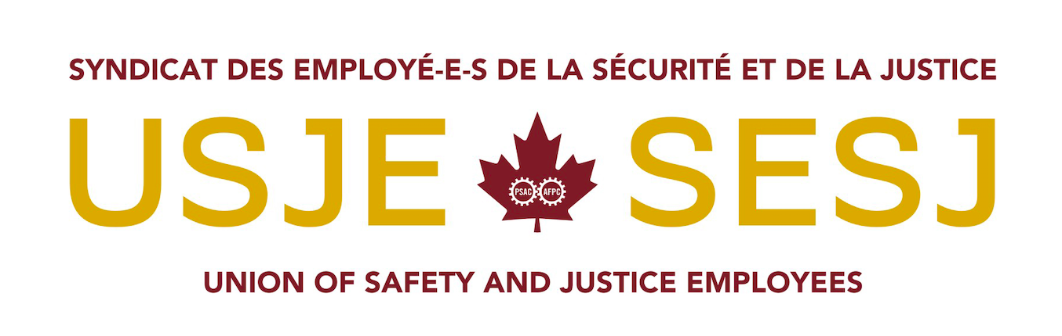
Stan Stapleton and David Neufeld’s speaking notes (10 minutes)
for HESA appearance regarding COVID-19 on June 15, 2020

-Check against delivery-

Delivered by Stan Stapleton:

USJE’s role and work

- Good afternoon. My name is Stan Stapleton and I am the National President of the Union of Safety and Justice Employees – also known as USJE.

- As a national organization representing employees working on the fronlines of the pandemic, I am very appreciative to be here with my colleague, David Neufeld, who is the National Vice-President for USJE.

- USJE represents over 16,000 Federal Public Service employees who work for 18 federal departments and agencies in a safety or justice capacity. However, the largest number work for the Correctional Service of Canada.

- Unlike the Union of Canadian Correctional Officers (UCCO), who have a security function in federal penitentiaries, USJE represents a diverse range of employees with crucial rehabilitative and administrative functions, including:

- food service officers
- parole and program officers
- teachers
- managers of assessment and intervention
- facilities and maintenance crews
- licenced practical nurses

- Hundreds of federal parole officers and case management teams from coast to coast oversee the re-integration of federal offenders. Their job is to ensure that federal offenders across the country adhere to their supervision plans, and are not at risk of re-offending.

Challenges regarding COVID-19

- I will be very honest with you. When COVID-19 hit, I do not believe we were prepared. Whatever pandemic protocols may have been in place were not immediately applied within CSC.

- On March 18, I wrote a letter to Commissioner Anne Kelly appealing to her to immediately implement proactive measures to,
- Minimize the spread of COVID in federal prisons
- Contain the footprint in the community

- We needed CSC to do what was effectively being done in Canada’s long term care homes:
- heavily control who was coming in and going out of federal penitentiaries
- significanty increase cleaning and sanitization protocols
- ensure appropriate use of PPE, and encourage face coverings
- begin widespread testing
- stop employees from working at multiple sites
- isolate presumptive cases (employees or offenders)

- For several weeks, we found that new protocols were not always applied consistenty,
such as:
- limited access to testing, and PPE
- sanitization was inadequate
- employees were moving between sites
- food delivery within affected prisons was presenting opportunities for further infection
- there were not enough laptops to enable work from home

- Quite frankly, when considering the living and working conditions at CSC during this pandemic, it is remarkable that major outbreaks were contained to five federal sites - and two deaths.

- Although extremely unfortunate, it could have been much worse. USJE’s senior leaders worked around the clock for several weeks to highlight challenges, gaps, oversights and opportunities to do things better when it came to COVID-19.

- One could say that we were relatively lucky. However, many CSCis employees working at full capacity and under an enormous stress during COVID would not view the situation so favourably.

- Thankfully, at this stage CSC and its union partners are in a much better place.

- This is in part because of the creation of a Joint Transition Task Force established by CSC, USJE, and other labour partners. The Task Force is something USJE called for in order to keep employees and offenders safe.

- The work of this Task Force has been very encouraging in terms of of the level of respect and engagement. We commend Bev Arseneault’s leadership with this Task Force

- I believe it could represent a new direction in how CSC treats its labour partners who have first hand knowledge of the challenges on the ground.

- I will now turn it over to my colleague David Neufeld.

Delivered by David Neufeld:

Recommendations to ensure the safety and security of employees and inmates regarding COVID-19

- As we begin to enter a “reset” phase of this pandemic, it is imperative that USJE work very closely with CSC and other stakeholders to:

- firstly, critically evaluate the effectiveness of the protocols put in place because of COVID-19, and determine what could be done better and how

- secondly, assess what is needed in this “new normal” environment for operations to continue effeciently and safely; while also

- beginning preparing immediately for future waves and challenges

- To do so, we have identified the following recommendations:

1) USJE is encouraged to see greater collaboration between our organization and CSC. This meaningful joint-work is already yielding positive outcomes for employees, offenders, institutions and facilities as a whole.

- USJE is committed to working closely with all stakeholders to ensure we take the time to critically reflect on the past few months - as well as act now to mitigate the impacts of a potential future pandemic.

- We believe the work of the Task Force must continue for a minimum of 1 year until we are safely behind this pandemic.

2) From the onset, safety measures must meaningfully take into account input from front line employees who work within the institutions, Community Correctional Centres and Community Parole Offices.

- In the early days, USJE members across the country have reported immense frustration in having their feedback disregarded by CSC management. Many felt the lives of offenders and employees were on the line, especially in outbreak sites where hundreds of offenders became ill.

- Our members are often the people who will be putting the new protocols into place, so their buy-in is paramount. No one understands operational considerations better than those who see their impacts daily. Their input matters a great deal and needs to be treated with respect.

3) For service levels to continue at their pre-pandemic standards, more resources – especially human resources – will be required.

- Many CSC employees have adapted their work to be in line with social distancing and other COVID-19 requirements.

- For example, a CSC program officer in the community who is in charge of delivering a weekly rehabilitation program to a group of ten offenders now has to meet individually with each one every week through video or teleconference.

- Not only will this require far more time to accomplish, it means each offender must have access to a smart phone or device, reliable internet connection, and a quiet place to speak with the instructor.

- Sufficient human resources are imperative to maintaining the required ‘frequency of contact’ with offenders. Meaningful frequency of contact is critical to ensuring proper supervision and rehabilitation, as well as public safety.

- For some, COVID-19 has only worsened workload issues and stress levels given the realities of working differenty.

4) Sanitation processes must be improved.

- COVID-19 has forced us to take a much closer look at cleaning protocols within CSC. CSC has just recently committed to the Public Health Agency of Canada standard.

- Over the past few months, employees have worked hard to contribute to enhanced cleaning efforts, even if not part of their official duties.

- However, the current practice of relying on a small number of offenders to do the majority of sanitization in very large pentitentaries - with little or no training in pandemic standards – is irresponsible.

- Contracting these critical tasks to outside agencies with highly transient employees is not the answer. Using outside cleaning contractors who enter a number of sites increases the chances of the virus spreading between institutions.

- We witnessed this during the outbreak at Mission Institution in B.C., where cleaners were going between two different penitentiaries during the same week.

- Additionally, interview rooms for multiple staff to meet offenders in federal prisons are often extrenely small and not cleaned regularly.

- CSC penitentaries and Community Correctional Centres carry the same risk as Canada’s long term care homes. We urge CSC to hire full-time properly trained cleaning professionals in each institution, Community Parole Offices, and Community Correctional Centres.

- Community footprint

- Community parole officers and case management teams have significantly decreased their footprint and reduced community contagion through delivering programs by telephone or video.

- They are also providing supervision by reducing the number of times an offender travels to a Community Parole Office, or by meeting the offender in the community at a safe distance.

- Case management teams in many instances can effectively work from home. In light of the prospect of a second wave, USJE strongly recommends no meaningful change to this modified approach to overseeing offenders in the community until Canada is confident that we are past a second wave.

Conclusion

- In closing, we urge committee members to consider how the federal government can assist the federal correctional system with the proper resources to maintain this “new normal.”

- Additonal human resources, a contained footprint, and more robust cleaning practises are imperative to keeping offenders, employees and Canadians safe.

- The federal government must also ensure that public health agencies throughout Canada offer widespread testing to offenders and employees.

- CSC must continue to foster ongoing collaboration with its labour partners and front line employees.

- Thank you for your time. We are pleased to answer any of your questions.

***

